Suggestions for Using the Kit Resources

1. Separating Mixtures

Gravel, sand and magnetic metal
This problem could be presented in the context of separating the components of builder’s rubble in order to recycle them. Ask pupils to suggest suitable methods before showing them the equipment (sieves and magnets)
Note that a magnet will only attract magnetic metals (iron, steel, nickel and cobalt)

Sand and salt
This problem could be presented in the context of separating pure sand and salt from the raw material rock salt, which is mined in Cheshire. A sample of rock salt is also provided for observation. It is used for ‘gritting’ roads in winter.
To separate the mixture:
- Put a couple of scoops into a mixing container
- Add 50ml water
- Stir to dissolve the salt
- Filter, using a funnel lined with folded filter paper (see diagram below), Rest the funnel over a beaker. The sand is held back by the filter paper and the ‘salty water’ solution drains through into the beaker
- Unfold the filter paper and leave in a warm place for the sand to dry
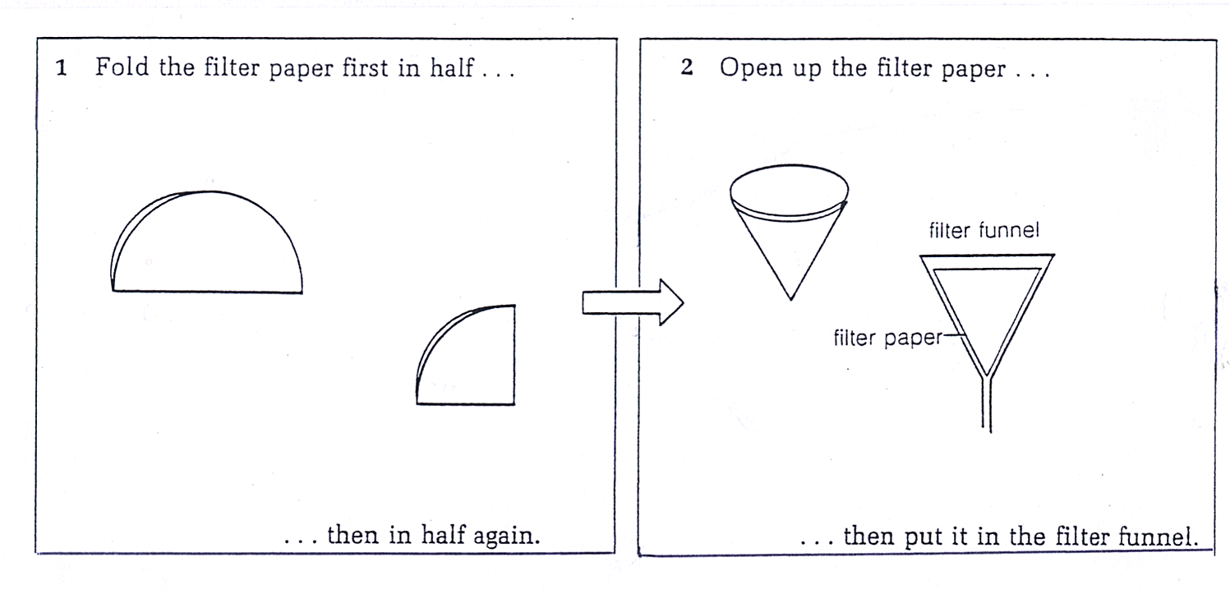
- Pour the salty water into the base of a Petri dish and leave in a warm place for the water to evaporate

Separating a mixture of dyes by chromatography
This problem could be presented in the context of a forensic science investigation e.g which ink was used to write a ransom demand?

Use the ‘chromatography kits’, strips of blotting paper and plastic beakers.
- Draw a pencil line about 2cm up from the bottom of a strip of chromatography paper
- Use a yellow plastic ‘dropper’ to put a small spot of food colouring on the centre of the line. Keep adding more spots in the same place to build up a concentrated spot about 5mm in diameter
- Leave to dry for a few minutes
- Put a small amount of water in a beaker
- Stand the chromatography paper in the beaker so that the lower edge just dips into the water and the coloured spot is above the water.
- Leave for about 15 minutes
- The dyes in the mixture will separate depending on how soluble they are in water and how quickly they move through the paper

The process can be repeated with the other food colourings and also with the ink in felt tip pens (a set is provided). More suggestions are given on page 16 of the CLEAPSS booklet ‘Safe Use of Household and Other Chemicals’ (enclosed with notes)
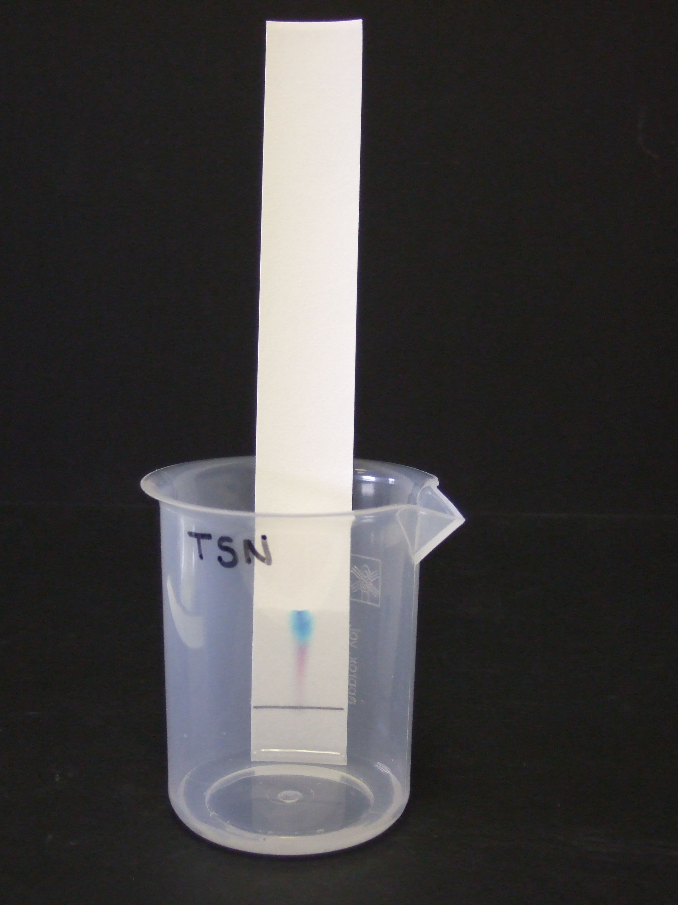
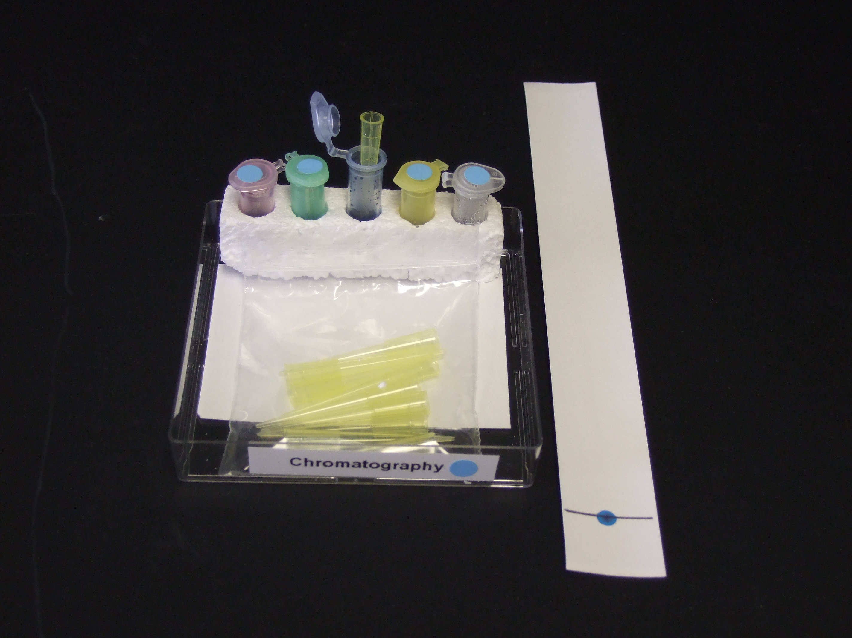
2. Dissolving

Each ‘Does it Dissolve?’ kit contains samples of 6 solids:
salt, talc, sugar, bicarbonate of soda, flour, cream of tartar
Each group will also need:
6 mixing containers, 100ml measuring cylinder, 6 plastic teaspoons, jug of water

- Pour 50ml of water into a mixing container
- Add a level teaspoon of one of the solids
- Stir gently for a few minutes and then leave to stand
- Repeat with the other solids
- Observe and record how well each solid has dissolved

For more background information and further suggestions for activities refer to pages 7-9 in the CLEAPSS booklet (enclosed with notes)

3. Mixing and Changing

Pupils’ ‘Mix and Change’ Kits
Each ‘Mix and Change’ kit contains the following household chemicals:
Vinegar, yeast, sugar, baking powder, bicarbonate of soda, effervescent vitamin C tablets, Andrews salts
Each group will also need:
5 mixing containers, 100ml measuring cylinder, plastic teaspoon, jug of water

- Pour 40 ml of warm water (about 40ºC) into a mixing container; add a teaspoon of sugar and a teaspoon of dried yeast. Stir gently and leave in a warm place for about 10 minutes
- Pour 40 ml water into a mixing container; add a teaspoon of baking powder
- Pour 40ml water into a mixing container; add a teaspoon of Andrews salts
- Pour 40ml water into a mixing container; add a piece if vitamin C tablet
- Pour 40 ml vinegar into a mixing container; add a teaspoon of bicarbonate of soda
Observe and record what happened in each mixture. (In each case, the bubbles of gas produced are carbon dioxide)

Teachers’ Mixing Kit

This contains some substances that could present a hazard if used incorrectly by pupils. For example, ‘Instant Snow’ will swell up to many times its volume when in contact with water and so could be dangerous if put into the mouth. Other substances are very messy (corn oil) or needed in quite large quantities (custard powder) For these reasons, the following mixtures should be carried out as teacher demonstrations

- Add a scoop of ‘Instant Snow’ to a mixing container; slowly add 100ml water. (The resulting material can be disposed of safely with normal classroom waste)

- Pour 200ml water into a mixing container; add a scoop of ‘Slush’ powder. (The resulting material can be disposed of safely with normal classroom waste)

- Pour 25ml water into a mixing container; add a scoop of custard powder and stir using a metal spoon; continue adding scoops of custard powder until the mixture is a hard solid when hit firmly with the spoon but will still flow like a liquid when moved gently

- Pour 25 ml water into a mixing container; add 25 ml of corn oil, stir with plastic rod and leave to stand. The oil will form a layer on top of the water (the 2 liquids are immiscible – they do not mix) Now add a few drops of Fairy Liquid to the mixing container and stir again. A creamy emulsion should form as the detergent emulsifies the oil (breaks it up into tiny droplets)

4. Extension Activities
Pupils could plan investigations to find out:
- Whether salt is more soluble than sugar (by comparing how much of each solid can be dissolved in the same volume of water)
- Which factors affect the rate of dissolving (e.g. water temperature, stirring, particle size)
These investigations provide ideal opportunities to discuss different variables and the importance of designing a fair test.

